Automated Multi-View Cardiac Cine MRI Segmentation and Ejection Fraction Estimation Using U-Net

Author: Youssef Sharabas
Abstract

Segmentation of cardiac structures in Cine MRI is essential for accurately assessing cardiac function, including Left Ventricular Ejection Fraction (LVEF), which is an important biomarker for diagnosing and predicting heart failure. This paper introduces a fully automated pipeline for multi-view cardiac segmentation and EF estimation that uses a U-Net convolutional neural network trained separately on three standard imaging planes: Short Axis (SAX), 2-Chamber (2CH), and 4-Chamber (4CH). Each model is optimized with a combined Dice and Cross-Entropy loss function and trained for 15 epochs using AdamW optimization and cosine annealing scheduling. After segmentation, we estimate Ejection Fraction from the SAX view using Simpson’s biplane method, which adds up LV cavity volumes across all short-axis slices and cardiac phases to determine end-diastolic (EDV) and end-systolic (ESV) volumes. We evaluate the models using Dice Similarity Coefficient (DSC), 95th-percentile Hausdorff Distance (HD95), Average Surface Distance (ASD), and Pearson correlation with ground-truth LVEF. The proposed system provides a clinically interpretable and efficient solution for automated cardiac function analysis.

1. Introduction
Cardiovascular disease is the top cause of death globally, leading to about 17.9 million deaths each year. Left Ventricular Ejection Fraction (LVEF), which measures the percentage of blood pumped from the left ventricle with each heartbeat, is one of the most crucial metrics for evaluating heart function. An LVEF below 40% indicates Heart Failure with Reduced Ejection Fraction (HFrEF). Values between 40% and 49% suggest mildly reduced function (HFmrEF), while values at or above 50% represent preserved function (HFpEF).
Cardiac Magnetic Resonance Imaging (CMR), especially Cine MRI sequences, is the top choice for assessing the volume of cardiac chambers. This is due to its excellent soft-tissue contrast, reliability, and lack of ionizing radiation. However, manually outlining cardiac structures in all slices and phases is slow, depends on the operator, and can vary from one observer to another. Automated segmentation using deep learning provides a way for consistent, quick, and scalable analysis.
This work presents a U-Net based segmentation system that works across three standard CMR views (SAX, 2CH, 4CH) at the same time. It integrates the segmentation results from the SAX view into a downstream Simpson’s method pipeline to estimate LVEF for each patient. The system is fully implemented in PyTorch, trained on the CineMulti dataset, and provides structured per-patient EF predictions in JSON format.
The main contributions of this work include:
- A view-specific U-Net trained separately for SAX (4 classes), 2CH (3 classes), and 4CH (6 classes) segmentation.
- A combined Dice and Cross-Entropy loss function for strong multi-class training despite class imbalance.
- A post-processing pipeline that includes connected-component retention and estimation of EF using Simpson’s biplane method.
- Per-epoch metric logging (DSC, HD95, ASD, EF PCC) with automatic chart generation.
- A structured JSON output (ef_predictions.json) linking patient identifiers to predicted EF values.

2. Related Work

2.1 Cardiac Segmentation
Ronneberger et al. (2015) introduced the U-Net architecture, which has become the standard for biomedical image segmentation. Its encoder and decoder structure, along with skip connections, helps the network recover fine details lost during downsampling. This makes it especially effective for small anatomical structures. Later works, like nnU-Net (Isensee et al., 2021), showed that well-tuned U-Net pipelines can compete with more complex models in medical segmentation tests.
The ACDC (Automated Cardiac Diagnosis Challenge) and M&Ms (Multi-Centre, Multi-Vendor) benchmarks have pushed for consistent evaluation of cardiac segmentation. The best methods achieved DSC values over 0.90 on LV cavity segmentation for SAX views. Researchers have looked into multi-view approaches that use SAX, 2CH, and 4CH planes together to improve consistency and cut down on view-specific artifacts.

2.2 Ejection Fraction Estimation
EF estimation from segmentation outputs usually uses Simpson’s rule, also known as the method of disks. This method estimates ventricular volume by adding up the areas of LV cavity cross-sections from consecutive slices, weighted by slice thickness. The end-diastolic volume (EDV) is identified as the frame with the highest summed LV area, while the end-systolic volume (ESV) is the lowest. EF is calculated as (EDV − ESV) / EDV × 100 (%). Pixel-count proxies for volume, which are used here, have been shown to relate well to actual volumes when imaging parameters are consistent within a dataset.
Several studies have shown that EF can be directly estimated from image sequences using 3D-CNN or transformer-based architectures. However, segmentation-based methods maintain clinical interpretability and allow for the review of intermediate mask predictions. This is an important feature for clinical use.

3. Dataset
The CineMulti dataset provides Cine MRI acquisitions in NIfTI format (.nii.gz) for three standard cardiac planes: Short Axis (SAX), 2-Chamber long-axis (2CH), and 4-Chamber long-axis (4CH). Each plane has a corresponding directory of paired image and annotation files, with ground-truth segmentation masks provided for all frames.
Table 1 summarises the structure and annotation schema of the dataset.
View | Volume shape | # Classes | Class labels
SAX (Short Axis) | H × W × T × S | 4 | 0=BG, 1=LV-Myo, 2=LV-Cav, 3=RV-Cav
2CH (2-Chamber) | H × W × T | 3 | 0=BG, 1=LV-Cav, 2=LV-Myo
4CH (4-Chamber) | H × W × T | 6 | 0=BG, 1=LV-Cav, 2=LV-Myo, 3=RV-Cav, 4=RA, 5=LA
Table 1. CineMulti dataset structure and segmentation class definitions. BG = Background; LV = Left Ventricle; RV = Right Ventricle; Myo = Myocardium; Cav = Cavity; RA = Right Atrium; LA = Left Atrium.
SAX volumes are four-dimensional (H × W × T × S), where T denotes temporal frames across the cardiac cycle and S denotes the number of short-axis slice positions. Long-axis views (2CH and 4CH) are three-dimensional (H × W × T), iterating over temporal frames only. Ground-truth LVEF values used for Pearson correlation validation are provided in an accompanying spreadsheet (dataset.xlsx) under the “SAX” sheet.
Each input slice is pre-processed by per-slice z-score normalisation (μ = 0, σ = 1) and resized to 256 × 256 pixels using bilinear interpolation for images and nearest-neighbour interpolation for masks to avoid label blurring. The dataset is split into 80% training and 20% validation using a patient-stratified random shuffle, ensuring no patient appears in both splits.

4. Methodology

4.1 Network Architecture
The proposed model follows the original U-Net architecture of Ronneberger et al. (2015), implemented in PyTorch with Batch Normalisation. The network consists of an encoder path, a bottleneck, and a symmetric decoder path connected by skip connections that concatenate feature maps from encoder to decoder at matching resolutions.
The encoder comprises four DoubleConv blocks, each containing two 3×3 convolutions followed by Batch Normalisation and ReLU activation, followed by 2×2 max-pooling with stride 2. Feature channel sizes across the encoder are 64 → 128 → 256 → 512. The bottleneck DoubleConv block expands to 1024 channels. The decoder applies four transposed convolution upsampling steps (stride 2), concatenating the corresponding encoder feature map at each level. The final layer is a 1×1 convolution that projects to the view-specific number of output classes. Total model capacity is approximately 31 million parameters.
Table 2 details the architecture layer-by-layer.
Stage | Operation | Input channels | Output channels | Output size
Encoder 1 | DoubleConv → MaxPool 2×2 | 1 | 64 | 128×128
Encoder 2 | DoubleConv → MaxPool 2×2 | 64 | 128 | 64×64
Encoder 3 | DoubleConv → MaxPool 2×2 | 128 | 256 | 32×32
Encoder 4 | DoubleConv → MaxPool 2×2 | 256 | 512 | 16×16
Bottleneck | DoubleConv | 512 | 1024 | 16×16
Decoder 4 | TranspConv → concat → DoubleConv | 1024 | 512 | 32×32
Decoder 3 | TranspConv → concat → DoubleConv | 512 | 256 | 64×64
Decoder 2 | TranspConv → concat → DoubleConv | 256 | 128 | 128×128
Decoder 1 | TranspConv → concat → DoubleConv | 128 | 64 | 256×256
Output | Conv 1×1 | 64 | C | 256×256
Table 2. U-Net architecture. C = number of output classes (4 for SAX, 3 for 2CH, 6 for 4CH). Input size is 1×256×256.

4.3 Training Protocol
Three independent models are trained, one per view, following a sequential order: 2CH → 4CH → SAX. All training runs share the following hyperparameter configuration:
Hyperparameter | Value
Epochs | 15
Batch size | 32
Input resolution | 256 × 256 pixels
Optimiser | AdamW
Learning rate | 1 × 10⁻⁴
Weight decay | 1 × 10⁻⁵
LR scheduler | Cosine Annealing
ηₘᵢⁿ (min LR) | 1 × 10⁻⁶
Train / Val split | 80 / 20 %
Model selection | Best validation Dice
Table 3. Training hyperparameters shared across all three views.

4.4 Data Augmentation
To reduce overfitting and improve model generalisation, the following stochastic augmentations are applied per slice during training only, with no augmentation applied at validation or inference:
- Random horizontal flip
- Random vertical flip
- Random 90° rotation
- Random brightness and contrast jitter

All augmentations are applied consistently and identically to the image slice and its corresponding segmentation mask to maintain anatomical correspondence. Mask augmentations use nearest-neighbour interpolation to preserve integer class labels.

4.5 Post-Processing
After inference, a connected-component retention step is applied to each predicted class map: for every foreground class c, all disconnected regions are identified and only the largest connected component is retained. This removes spurious isolated predictions that arise from anatomical noise or boundary ambiguity, which is particularly important for accurate surface distance metric computation and EF volume estimation.

5. Results
Table 4 presents the best-epoch validation metrics for each view. Metric values are to be populated upon completion of training runs. The table structure is provided here for completeness.
View | Best DSC ↑ | HD95 (px) ↓ | ASD (px) ↓ | EF PCC ↑
SAX (Short Axis) | 0.9336 | 4.11 | 1.41 | 0.9613
2CH (2-Chamber) | 0.9194 | 5.37 | 1.9 | N/A
4CH (4-Chamber) | 0.9284 | 4.12 | 1.47 | N/A
Table 4. Best validation metrics per view. ↑ = higher is better; ↓ = lower is better. EF PCC is computed for SAX only.
The training and validation loss curves, per-epoch DSC progression, HD95, and ASD trends are visualized (Figure 2). A summary bar chart compares best-epoch vs. final-epoch DSC across all three views side-by-side(Figure 1).
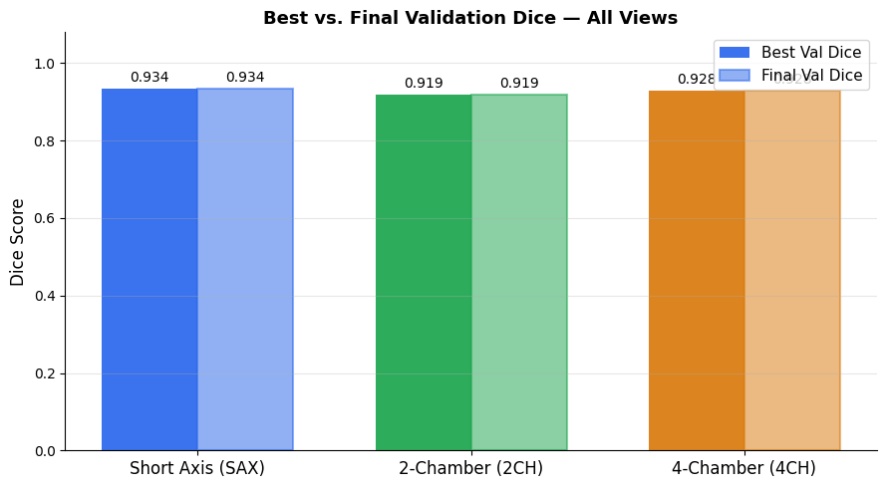
Figure 1: bar chart compares best-epoch vs. final-epoch DSC across all three views side-by-side
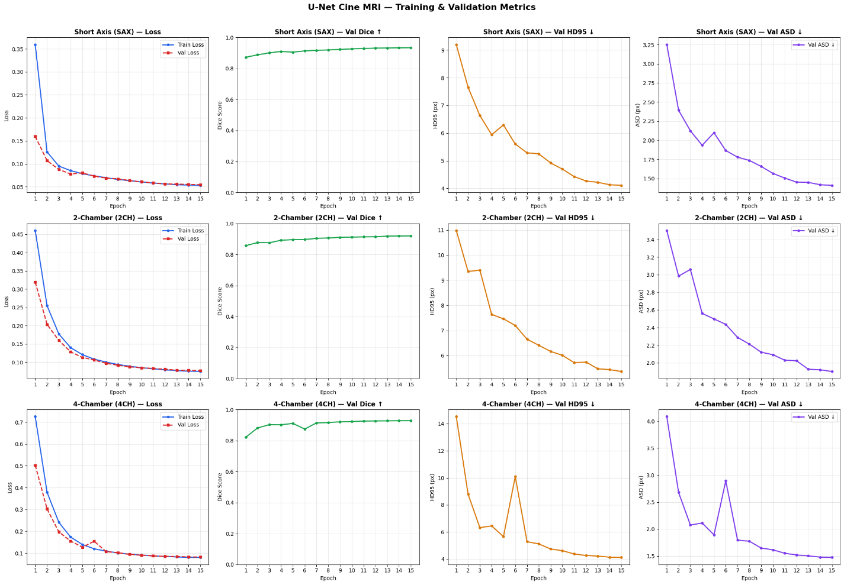
Figure 2:Training and validation loss curves, per-epoch DSC progression, HD95, and ASD
Ejection Fraction predictions from the SAX inference pipeline are serialised in ef_predictions.json. Validation against ground-truth LVEF values is reported as a scatter plot with Pearson r and Mean Absolute Error (MAE).

The colors in the Ground Truth and Prediction masks represent different anatomical regions (segmentation classes) of the heart in the cardiac MRI images shown in the following figures(3,4,5).
From your visualization, the segmentation appears to use 4 foreground classes + background:
- Dark Purple → Background (non-heart region)
- Green → One cardiac chamber/wall region
- Yellow → Another cardiac chamber
- Cyan / Teal → Another anatomical structure
- Blue / Indigo → Another cardiac structure
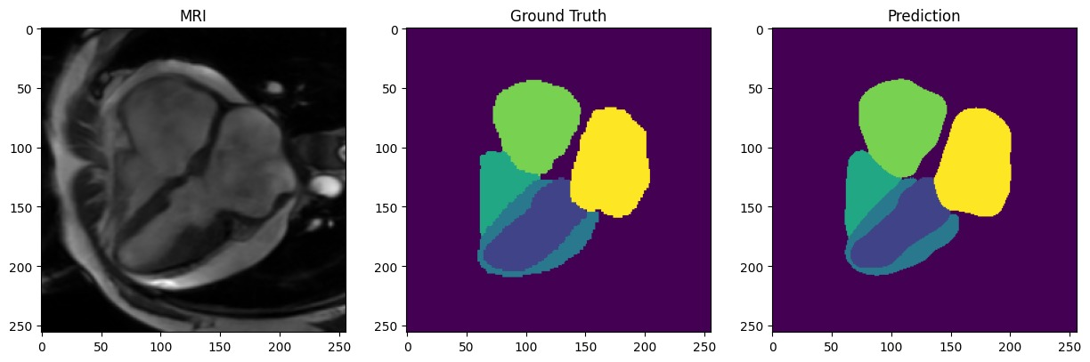
Figure 3:heart in the cardiac MRI images
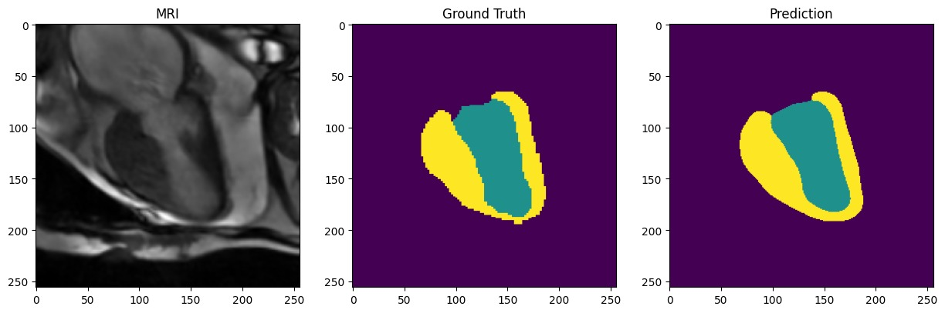
Figure 4:heart in the cardiac MRI images
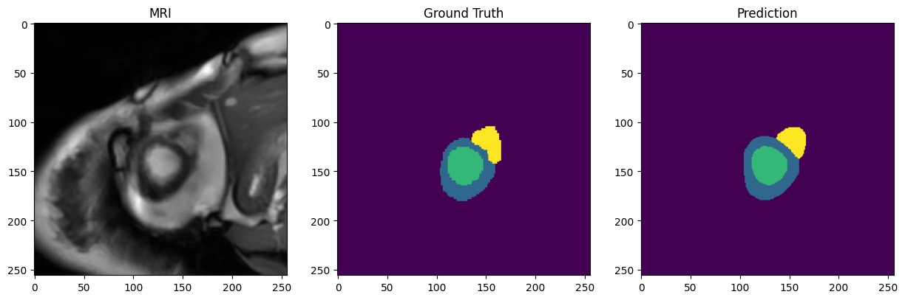
Figure 5:heart in the cardiac MRI images

6. Conclusion
This paper presents a complete automated pipeline for cardiac structure segmentation and Ejection Fraction estimation from multi-view Cine MRI. Three view-specific U-Net models were trained on the CineMulti dataset with a combined Dice + Cross-Entropy loss, AdamW optimisation, and cosine annealing scheduling. Per-epoch metrics were logged and visualised for model monitoring. Ejection Fraction was estimated from the SAX segmentation using Simpson’s method and output as a structured JSON mapping patient identifiers to predicted EF values in percent.
The system provides a clinically interpretable, modular, and reproducible framework that can serve as a baseline for more advanced cardiac analysis methods. Future work will explore multi-task learning across views, physical-unit volume calibration using NIfTI voxel spacing metadata, temporal consistency constraints across cardiac phases.

References
[1] Ronneberger, O., Fischer, P., & Brox, T. (2015). U-Net: Convolutional networks for biomedical image segmentation. In Medical Image Computing and Computer-Assisted Intervention (MICCAI), 234–241.
[2] Isensee, F., Jaeger, P. F., Kohl, S. A., Petersen, J., & Maier-Hein, K. H. (2021). nnU-Net: A self-configuring method for deep learning-based biomedical image segmentation. Nature Methods, 18(2), 203–211.
[3] Petitjean, C., & Dacher, J. N. (2011). A review of segmentation methods in short axis cardiac MR images. Medical Image Analysis, 15(2), 169–184.
[4] Bernard, O., et al. (2018). Deep learning techniques for automatic MRI cardiac multi-structures segmentation and diagnosis: Is the problem solved? IEEE Transactions on Medical Imaging, 37(11), 2514–2525.
[5] Campello, V. M., et al. (2021). Multi-Centre, Multi-Vendor and Multi-Disease Cardiac Segmentation: The M&Ms Challenge. IEEE Transactions on Medical Imaging, 40(12), 3543–3554.
[6] Lang, R. M., et al. (2015). Recommendations for cardiac chamber quantification by echocardiography in adults: An update from the American Society of Echocardiography. Journal of the American Society of Echocardiography, 28(1), 1–39.
[7] Loshchilov, I., & Hutter, F. (2019). Decoupled weight decay regularization. In International Conference on Learning Representations (ICLR).
[8] Milletari, F., Navab, N., & Ahmadi, S. A. (2016). V-Net: Fully convolutional neural networks for volumetric medical image segmentation. In 3D Vision (3DV), 565–571.

